PROJECT REPORT: INTEGRATED LIBRARY AND STAFF MANAGEMENT SYSTEM
1. Project Title & Overview
- Project Title: Integrated Library and Staff Management System
- Developer: Shubham Krishna
- Development Date: June 2026
- Technology Stack: Spring Boot (Java), MongoDB, HTML5/CSS3/JavaScript, Postman
Description
The Integrated Library and Staff Management System is a unified, full-stack enterprise application designed to streamline core administrative workflows within an academic or public library environment. Unlike standalone solutions that isolate asset tracking from human resource management, this platform integrates a Library Asset Management Module alongside an Employee Attendance & Time-Tracking Module under a single, highly responsive ecosystem.
The system relies on a high-performance Java backend built on the Spring Boot framework, which interfaces natively with a NoSQL MongoDB instance. The frontend features a sleek, dark-themed dashboard operating on a dynamic tabbed interface, eliminating the need for multi-page reloading and maximizing operational efficiency.
2. Project Objectives
The primary objectives behind developing this integrated architecture include:
- Unified Administrative Control: Centralizing inventory tracking (books) and operational oversight (staff activity) into a singular local server configuration (localhost:8080).
- Automated Lifecycle Management: Digitizing manual tasks such as borrowing, returning, and tracking books, as well as shifting staff status records away from paper logs.
- Real-Time Temporal Tracking: Implementing an automated timestamp logging engine for employee clock-ins and clock-outs to capture accurate workforce shift data.
- High-Throughput Storage: Utilizing a non-relational, schema-less MongoDB database to accommodate flexible document structures and ensure low-latency data mutations.
- Decoupled API Verification: Ensuring system robustness by conducting thorough validation of stateful CRUD routes using Postman independently of the frontend user interface.
3. Core System Operations
The system exposes specialized RESTful APIs to handle state mutations across two separate data collections.
A. Library Inventory Operations
The book inventory tracking module implements standard persistent behaviors:
- Create (Add Book): Inserts new literary assets with properties detailing title and category classification.
- Read (Fetch Inventory): Pulls the complete array of catalog items to dynamically display active titles to the dashboard view.
- Update (State Shift - Borrow/Return): Modifies the contextual availability string state (borrowed: true/false), altering visual cues on the dashboard interface.
- Delete (Purge Asset): Permanently drops specific document items from the active records pool via their explicit primary key reference.
B. Workforce Management Operations
The employee tracking module monitors staff shifts via independent event endpoints:
- Staff Registry (Create/Remove): Provisions and de-provisions employee profiles with assigned functional departments.
- Clock-In Sequence (Update): Automatically captures a highly precise, formatted string value of the exact check-in time (yyyy-MM-dd hh:mm a) and writes it instantly into the active document database.
- Clock-Out Sequence (Update): Appends a completion timestamp onto the worker's record indicating shift conclusion.
4. Technical Aspects & Architecture
The system utilizes a structured, modular architecture following a decoupled client-server model.
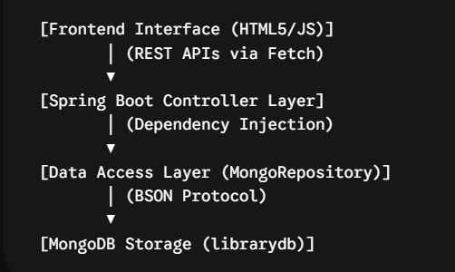

Backend Architecture (Spring Boot)
The server logic relies on a strictly typed, layered framework architecture designed around three key components:
- The Controller Layer (BookController, EmployeeController): Maps logical URIs (/api/books and /api/employees), listens to inbound HTTP request verbs (GET, POST, PUT, DELETE), handles parameter extraction, and implements @CrossOrigin(origins = "*") to mitigate strict browser security blocks.
- The Model Layer (Book, Employee): Defines persistent POJO structures mapped directly to the BSON storage collections through spring-data annotations (@Document, @Id).
- The Repository Layer (BookRepository, EmployeeRepository): Leverages Spring Data MongoDB's inheritance structure to automatically synthesize complex database transaction mechanics without manual query scripting.
Database Design (MongoDB Compass Integration)
The persistent storage architecture operates locally over port 27017 within an independent database instance named librarydb. Data isolation is achieved across two distinct, scalable collections:
1. books Collection Sample Document
JSON
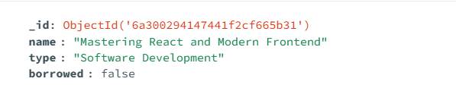
2. employees Collection Sample Document
JSON
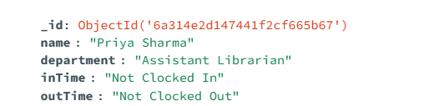
Frontend Implementation
The client UI layer is constructed inside an optimized single-file document utilizing vanilla web technologies. Key UI mechanics include:
- Asynchronous Processing: Harnesses the browser's native JavaScript Fetch API inside async/await structures to handle asynchronous network calls smoothly.
- Conditional Rendering: Evaluates current operational states (borrowed == true) on the fly to dynamically modify active template strings, swapping buttons and badge classes dynamically.
- Component-Free Layouts: Uses pure CSS structural variables to implement a modern, high-contrast dark aesthetic that adapts seamlessly to desktop display resolutions.
5. API Testing and Verification (Postman)
A core focus of this project was validating backend performance apart from the frontend UI. Postman served as the dedicated verification client.
API Isolation Method: Testing endpoints via Postman ensured that any unexpected interface behaviour could be cleanly classified as either a client-side layout glitch or a deep server-side logic exception (e.g., a 500 Internal Server Error caused by referencing a non-existent document ID).
By structuring the requests inside an isolated personal workspace collection, developers can store functional JSON payloads, analyze raw response payloads, and track performance across active routes.
6. Conclusion & Future Scope
Conclusion
The Integrated Library and Staff Management System successfully establishes that a monolithic Spring Boot backend can cleanly manage separate business domains simultaneously. By structuring our folders with precise component grouping, the backend automatically registers new components, enabling multiple database operations to run on a single local server context. This single-host architecture dramatically reduces system resource utilization while delivering lightning-fast request-response loops for both asset tracking and employee logging workflows.
Future Scope
While highly stable in its current form, the platform is designed to seamlessly scale into a full-scale cloud-native enterprise application. Future development phases will prioritize:
- Role-Based Security: Integrating Spring Security and JSON Web Tokens (JWT) to lock administrative routes behind role-defined staff access.
- Advanced Analytics: Building query methods within the repository layer to output detailed operational insights, such as high-demand book categories and historical shift summaries.
- Relational Mapping: Adding a history log collection to track past transactions when a book is borrowed or an employee clocks in.
Proof of Work:-

